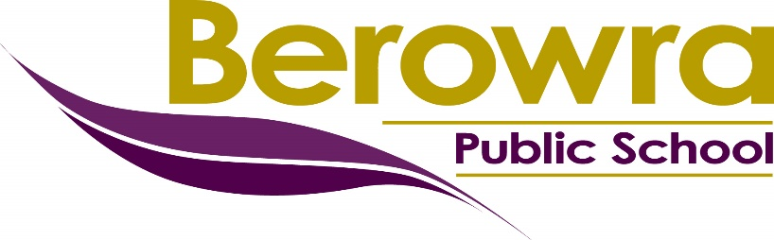

School Uniform Procedures

Purpose

At Berowra Public School we value the wearing of school uniform as it promotes a sense of belonging for our students and creates a positive identity for the school community. School uniforms also contribute to the personal safety of students by preventing physical injury and allowing easier recognition of students inside the school and in the community.

Our school uniform has been designed and chosen by BPS students to be functional, non-gender specific, smart, and affordable. Our local school uniform requirements are the result of formal consultation with students, teachers and other staff, parents or carers, and the school community (including the P&C).

Responsibilities

Principal and Assistant Principals
- lead the development and review of local school uniform requirements
- lead consultation during a review of school uniform requirements
- oversee contract negotiations with school uniform suppliers (Principal)
- inform parents and carers of local school uniform requirements and carefully consider parent and carers concerns, and requests for exemptions
- provide assistance to families in need

Parents and Carers
- provide their child/children with a school uniform that meets the BPS school uniform requirements and raise any concerns with the principal or classroom teacher
- complete all ‘BPS Out of School Uniform’ notes that are sent home and provide valid reasons for your child/children being out of uniform

Students
- wear full school uniform, including sports uniform, that meets the BPS school uniform requirements during school hours, while travelling to and from school, and when engaged in school activities out of school hours

BPS School Uniform Requirements

Girls Summer Uniform
- Purple polo shirt with school logo
- Completely black skort or shorts (no logos)
- White ankle socks
- Completely black school shoes
- Black polo fleece jacket
- Wide brimmed school hat

Boys Summer Uniform
- Purple polo shirt with school logo
- Completely black shorts (no logos)
- White ankle socks
- Completely black school shoes
- Black polo fleece jacket
- Wide brimmed school hat

Sports Uniform
- House colour polo shirt
- Completely black skort or shorts (no logos)
- White ankle socks and track shoes
- Wide brimmed school hat

Girls Winter Uniform
- Purple polo shirt with school logo
- Completely black skort, shorts, jazz pants or trousers (no logos)
- White/black ankle socks (with trousers)
- Completely black school shoes
- Black polo fleece jacket
- Wide brimmed school hat

Boys Winter Uniform
- Purple polo shirt with school logo
- Completely black shorts or trousers (no logos)
- White/black ankle socks (with trousers)
- Completely black school shoes
- Black polo fleece jacket
- Wide brimmed school hat

Logos - School logo only on clothing, socks and hats, no other logos should be seen.

Shorts – Shorts must be of an appropriate length. Bike shorts and short shorts are not appropriate for school.

Tights and Leggings – Black tights and/or leggings are only to be worn under school uniform.

Jewellery – Bracelets, necklaces, rings, and earrings (other than studs or small sleepers) are not permitted to be worn at school. Watches can be worn and in the case of Smart Watches, must be on ‘school mode’, as per the BPS mobile phone procedure.

Accessories – Nail polish or false nails are not permitted to be worn at school. Hair that touches the shoulder must be pulled back. Small hair accessories are permitted in the school colours of purple, yellow and black.

Promoting the Wearing of Full BPS School Uniform

At Berowra Public School we use strategies to recognise and promote the wearing of school uniform in a positive and encouraging way including;
- publicising the school dress code
- ensuring all new parents to the school are provided with a copy of the dress code
- publishing the benefits of school uniform in the newsletters
- recognising students who wear school uniform through praise
- formal recognition of groups of students
- reference to the uniform as part of recognition and promotion of the spirit of the school
- reminders to students in practical classes that standards of dress have been agreed upon for the health and safety of students
- involvement of student leaders in developing, discussing and promoting school uniforms

Individual Students Who Persist in Not Wearing School Uniform

At Berowra Public School we may use the following strategies to assist students who persist in not wearing full school uniform
- speaking to the student (preferably in private) to encourage wearing of the school uniform
- providing a verbal warning to students
- notifying the parents of the uniform infraction through the ‘BPS Out of School Uniform Note’ to understand the reason/s for the infraction.
- inviting parents to the school to discuss the situation and negotiate an appropriate course of action with the student and parents.

Under certain circumstances, where the health and safety of the student or of other students would otherwise be compromised, students may be excluded from certain educational activities. Such action may also be required if a student’s clothing compromises agreed upon school uniform requirements and might be considered damaging to the image of the school in the larger community context. Alternative educational activities must be provided in such circumstances. With the above exceptions, no student will have their access to learning reduced because they are out of uniform. This includes their continued participation in essential curriculum activities.

Notification of School Uniform Infraction

If there is a reasonable reason why a child/children cannot wear full school uniform on a particular day, the parent or carer is to send an email to notify the classroom teacher explaining why.

If a child is at school not wearing full school uniform, and a reasonable reason has not been provided by the parent or carer, a ‘BPS Out of School Uniform Note’ will be sent home with the child/children. It is the responsibility of the parent or carer to return the note with an explanation as to why the child was out of uniform or explaining that they were unaware or that there was no reasonable reason.

Monitoring, Evaluation, and Review
Protocols are in place for families to be provided access to this policy and all relevant resources.
School executive will monitor the implementation of this policy, regularly review its contents to ensure relevance and accuracy, and update it as needed.

Resources

Berowra Public School Uniform Shop

https://berowra-p.schools.nsw.gov.au/uniform-shop.html

https://uniformshop.bps.org.au/

Department of Education School Uniform Policy

https://education.nsw.gov.au/policy-library/policies/pd-2004-0025

The department school uniform policy requires that schools set local school uniform requirements. Our BPS school uniform policy follows all legislative requirements, including the Anti-Discrimination Act 1977 and the Work Health and Safety Act 2011.

https://legislation.nsw.gov.au/view/html/inforce/current/act-1977-048
https://legislation.nsw.gov.au/view/html/inforce/current/act-2011-010

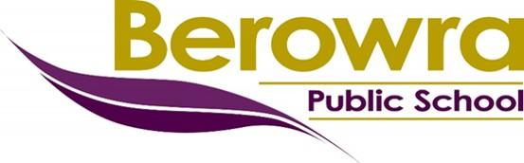
BPS Out of Uniform Note
Wearing the Berowra Public School uniform with pride promotes a sense of belonging and creates a positive identity for the school community.

____________________________ uniform did not follow the BPS School Uniform Policy today, ________________________.

The uniform infraction was ________________________________________________________________.

I was/was not aware that my child was out of uniform.
Reason: ________________________________________________________________________________

Parent/carer signature: ________________________

Please notify the school via email or a note if your child is out of uniform for a legitimate reason.
Berowra Public School Uniform Shop https://uniformshop.bps.org.au/
A copy of the School Uniform Procedures can be found on the school website https://berowra-p.schools.nsw.gov.au/about-our-school/rules-and-policies.html

BPS Out of Uniform Note
Wearing the Berowra Public School uniform with pride promotes a sense of belonging and creates a positive identity for the school community.

____________________________ uniform did not follow the BPS School Uniform Policy today, ________________________.

The uniform infraction was ________________________________________________________________.

I was/was not aware that my child was out of uniform.
Reason: ________________________________________________________________________________

Parent/carer signature: ________________________

Please notify the school via email or a note if your child is out of uniform for a legitimate reason.
Berowra Public School Uniform Shop https://uniformshop.bps.org.au/
A copy of the School Uniform Procedures can be found on the school website https://berowra-p.schools.nsw.gov.au/about-our-school/rules-and-policies.html

