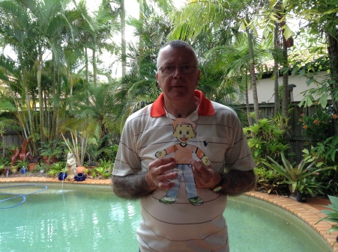

**Hi Boys and Girls in Year 2 at Berowra Public School,**

I am Finn Ludlow's Poppy and since **Flat Stanley** arrived at my house on the Gold Coast in Queensland he has been very active. He started off by having a swim in our swimming pool and then we went to the Burleigh Beach to play in the sand. He built a very big sand castle and then the waves washed it away.

After trying all the spare beds he picked the one he liked best and said that that was the one he would sleep in until he went home. He has been waking up very early and then jumps on my bed to wake me up. After we have breakfast we have been going for a walk along Burleigh Beach, and then going to the park to kick his football and play in the playground.

Each afternoon **Flat Stanley** watches his favourite TV shows before having his dinner and going to bed. He likes me to read him storey tale books, and tell him stories about his mother when she was a little girl.

We went on a picnic two days ago and had a very nice day. Yesterday **Flat Stanley** and I went to Sea World to see the Polar Bears, and he went on all the rides. After he ate a big ice cream he had chocolate ice cream all over his face and I had to take him into the wash room to clean him up.

I think I will miss **Flat Stanley** when he goes home as he has been very good and we have had a lot of fun together.

**Goodbye for now Finns Poppy.**

