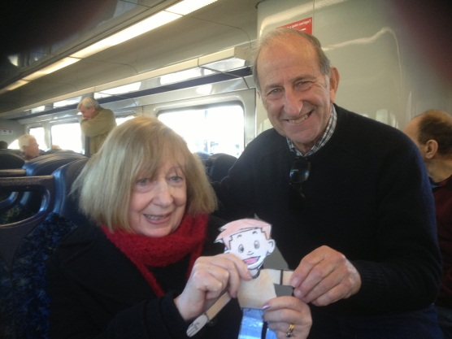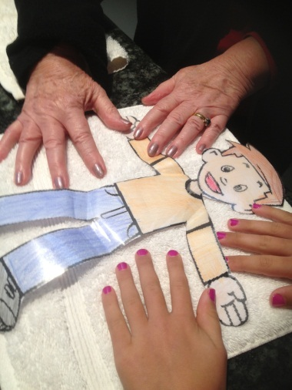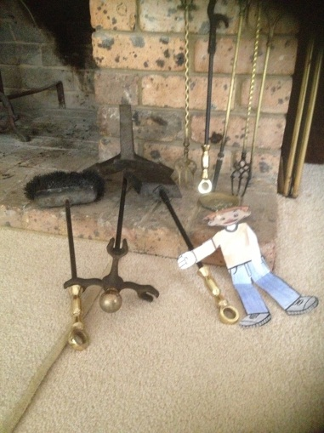

**FLAT STANLEY PR0JECT YEAR TWO, BEROWRA PUBLIC SCHOOL**

Visit to Papa and Granny Staniland

It was very exciting to get Flat Stanley in the mail in Frenchs Forest. We took him to Narrabeen Lakes where Mia and Darcy love to ride their bikes, and have a barbecue. There were people having fun on the Lake on sailboards so Flat Stanley was very happy to be invited to sail too. The wind blew hard and the sailboard tipped over, but Flat Stanley was all right as he floated across the water, and into shore. Everyone clapped to see Flat Stanley arrive safely.

We had very heavy rain and wind at our house one night. In the middle of the night when we were asleep we heard a huge crash which woke us up. Papa went to see what had happened. He found the fire tongs in the fireplace had been knocked over. Flat Stanley and Papa searched the house, and found sooty paw prints on the carpet and up the wall to a window. We realised a possum had fallen down the chimney and was looking for a way to escape outside. Being flat, Stanley was able to see the possum hiding, so Papa opened the back door and let the possum escape outside.

Mia and Flat Stanley came with Granny to her “Nail Lady”. Mia had fun looking at all the colours and chose one so she could have her nails painted too.

Mia made some yummy iced cakes. Flat Stanley watched them being made, but sadly as he is flat wasn’t able to have any! Boo Hoo!!

One day a man came to install a new cooktop in Granny and Papa’s granite bench. Flat Stanley got covered in dust so Granny had to wipe him!

Granny and Papa took Flat Stanley on the train to Bowral with some of their friends for the day. He loved looking out of the window to see the countryside flashing by (much more to see than in an envelope!).

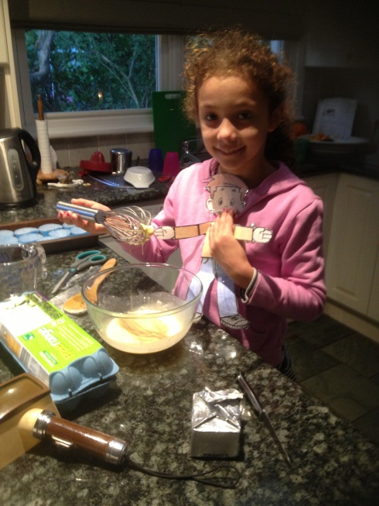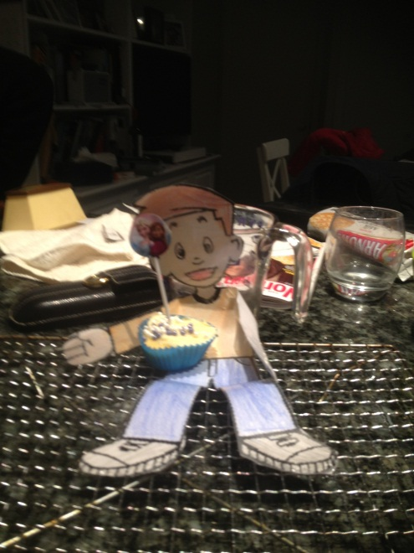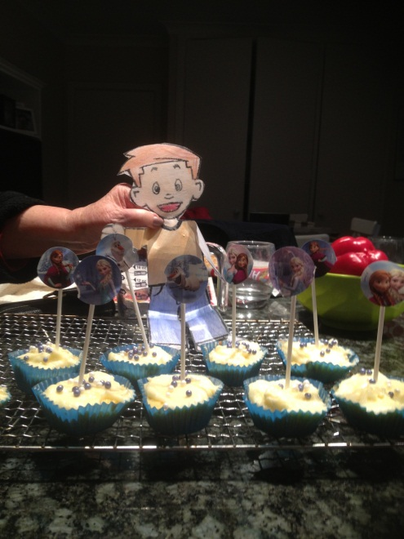Sadly it is time to return to school again. Granny and Papa put me in an envelope addressed to Year 2 Berowra Public School and into the letter box. Goodbye!