

Dear Zoe,

Thank you for sending Flat Stanley to visit us in Indianapolis in the state of Indiana in America. It was a long trip for him to the other side of the world but we were all very happy to see him when he arrived safely! Yesterday he came strawberry picking with us – they were delicious! The strawberries are very sweet and juicy because it is the beginning of summertime here. We hope to take him on some more adventures before he makes the long trip back to Australia! It takes him about 24 hours (one whole day and night) to travel all the way from where we are in the middle of America to Sydney.

He also got to celebrate Singapore’s 50TH Birthday.

Thank you again for letting him visit us!

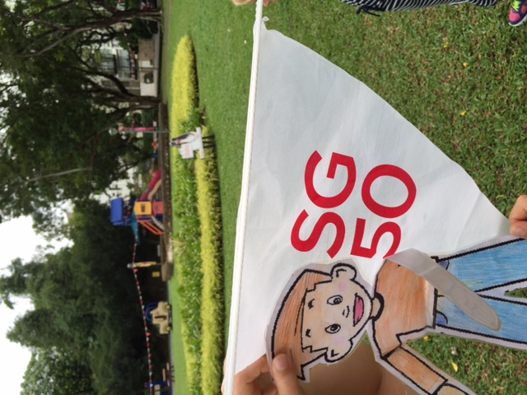From your friend,   
Harriet