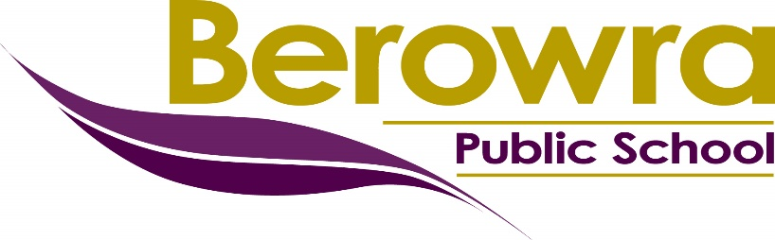

BEHAVIOUR MANAGEMENT PROCEDURES
Contents
Introduction 1
Aims 1
NSW Public Schools Behaviour Code 2
PBL Behaviour Matrix 3
Strategies and Practices to Promote Positive Student Behaviour 4
Positive Reward System 4
BPS Progressive Reward System 5
Strategies and Practices to Manage Inappropriate Student Behaviour 6
Classroom Management Procedures 6
Playground Management Procedures 6
Reflection Room 6
Behaviour Levels Procedure – 7
All behaviour levels commence at Level 0 each year 7
Inappropriate Behaviour Procedures for Kindergarten 8
Bullying 8
Monitoring and Evaluating 8
Berowra Public School Awards 9
Minor and Major Behaviour Incidents 10
Classroom Management Procedures Flowchart 11
Playground Management Procedures Flowchart 12
Behaviour Levels 13
Reflection Sheet 14
BEHAVIOUR CARD 15
Behaviour Card 16

Introduction

Berowra Public School supports the learning, wellbeing and safety of all students. Collaboration between staff, students and parents/carers is fundamental to maintain positive behaviour and effective discipline.

An effective discipline procedure is one that seeks to lead children towards high self-esteem and self-regulation. Consequently, effective discipline arises from positive relationships and from setting high but achievable expectations for behaviour.

At Berowra Public School our Behaviour Management Procedures aim to create an environment of mutual respect in which all students can grow, learn, and feel that they are safe and valued.

The procedures set out a balanced approach recognising student achievement and dealing with inappropriate behaviour.

Parents have a vital role to play in their children’s education. It is very important that they support their child’s learning and cooperate with the school. We are very conscious of the importance of having strong links with parents and good communication between home and school. We will inform parents throughout this process and we would appreciate it, if parents have concerns, that they make these known to the class teacher, stage supervisor or principal.

Aims

- Students will follow the school expectations and comply with staff directions regarding discipline and appropriate behaviour.
- Parents will support the school in the implementation of the Behaviour Management Procedures.
- Teachers will treat all students fairly and apply this policy in a consistent way.
- Every member of the school community will behave in a considerate way towards others.
- The school expectations, NSW Public Schools Behaviour Code and BPS Behaviour Management Procedures are known and understood by all school community members.
- Every member of the school community feels valued and respected.
- Students will be able to learn in a harmonious environment free of inappropriate behaviour.
- Teaching and learning will promote good relationships based on mutual respect and consideration for others.
- Children will learn in a safe, happy and secure environment and become positive, responsible and independent members of the community.
- Appropriate behaviour will be recognised, rewarded and all students will be encouraged to behave in this way.

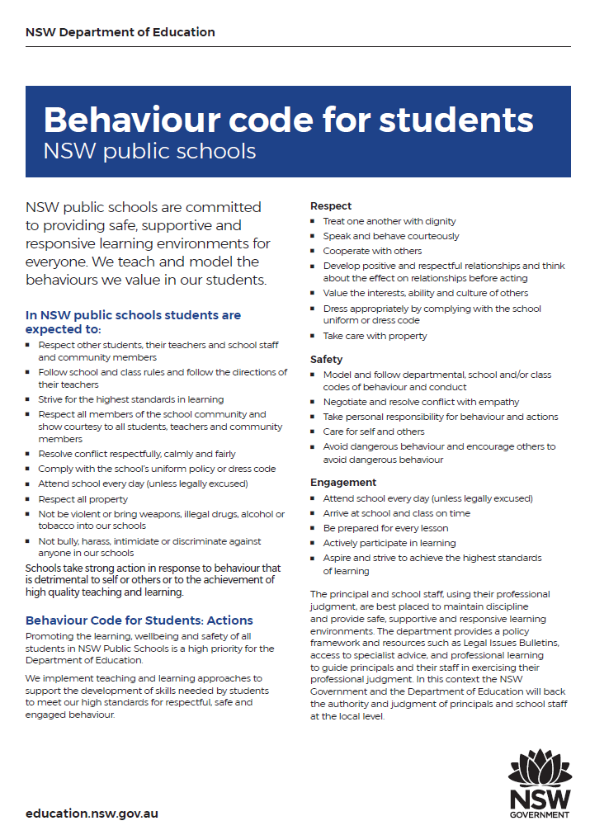
NSW Public Schools Behaviour Code

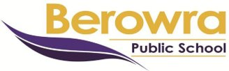
PBL Behaviour Matrix

 | RFF/Office | Eating Area/  COLA | Playground  asphalt/grass/ | Canteen | Toilets | Hall | PSSA/bikes/bus/outside school
Self | - Be in the right place at the right time  - Stay focused and on task | - Be in the right place at the right time  - Take care of your belongings | - Be in the right place at the right time  - Take care of your belongings  - Choose appropriate activities | - Be in the right place at the right time  - Spend your own money | - Be in the right place at the right time  - Wash your hands | - Be in the right place at the right time  - Take care of your belongings | - Be in the right place at the right time  - Take care of your belongings
Others | - Follow teachers’ directions the first time  - Keep hands, feet and objects to yourself  - Speak politely and act kindly | - Follow teachers’ directions the first time  - Keep hands, feet and objects to yourself  - Speak politely and act kindly | - Follow teachers’ directions the first time  - Keep hands, feet and objects to yourself  - Speak politely and act kindly | - Follow teachers’ directions the first time  - Keep hands, feet and objects to yourself  - Speak politely and wait your turn | - Follow teachers’ directions the first time  - Keep hands, feet and objects to yourself  - Speak politely and act kindly | - Follow teachers’ directions the first time  - Keep hands, feet and objects to yourself  - Listen attentively to all speakers | - Follow teachers’ directions the first time  - Keep hands, feet and objects to yourself  - Speak politely and act kindly
Community | - Give other students time and space to learn  - Use equipment properly/safely | - Keep the area clean and tidy  - Walk on asphalt | - Use equipment appropriately and safely  - Keep food away from grassed areas  - Walk on asphalt | - Keep the area clean and tidy  - Use facilities properly | - Keep the area clean and tidy  - Use facilities properly | - Take care of facilities  - Applaud appropriately | - Walk bicycles in school grounds  - Follow road rules  - Use facilities properly

Strategies and Practices to Promote Positive Student Behaviour

- The PBL Behaviour Matrix clearly defines behaviour expectations.
- Expected behaviours are explicitly taught by all staff members.
- Staff and students use common language regarding expected behaviour.
- Correct behaviours are taught and strengthened to replace inappropriate behaviours.
- A community understanding that positive and negative consequences for behaviour will be followed through with consistent, common practices.
- There is formal, informal and frequent use of positive rewards/reinforcers for appropriate student behaviour.
- Teacher student negotiation and discussion.
- A Behaviour Management Procedure which is designed to promote positive behaviour.
- All students are dealt with in a fair and equitable manner.
- Anti-Bullying Procedures are enforced and the Anti-Bullying Plan implemented each year.
- Anti-Bullying signs are displayed around the school.
- Child Protection and Drug Education lessons taught each year.

Positive Reward System

Berowra Public School is strongly committed to encouraging and rewarding achievement in all aspects of school life. We reward positive behaviour, as we believe that this will develop an ethos of kindness and cooperation. Our positive system of rewards will include:
- certificates of merit presented in school assemblies
- progressive and integrated system of rewards based on the collection of certificates of merit
- special mention/recognition in class, assembly and/or school newsletter
- verbal praise and feedback about students’ learning and behaviour
- informal referral to the executive or principal for commendation
- individual classroom rewards systems
- certificates, books, trophies and prizes awarded at the Presentation Day assembly
- positive playground behaviour is recognised and rewarded with ‘Gotchas’ with the winning house receiving a suitable reward each term (eg. BBQ, iceblock)

BPS Progressive Reward System

AWARD | ACHIEVEMENT OF AWARDS | ACKNOWLEDGEMENT OF AWARDS
ACADEMIC/ CITIZENSHIP  MERIT | Teacher awards Merit Certificates for academic achievement and/or good citizenship. | Each class teacher selects 2 students for awards each week.  Merit Certificates are presented at the weekly assembly.  Noted in school newsletter.
HONOUR  BRONZE LEVEL | Student has earned 4 Merit Certificates which converts into an Honour Certificate. | Honour Certificate presented at whole school assembly.  Noted in school newsletter.
PENNANT  SILVER LEVEL | Student has earned 3 Honour Certificates which converts into a Pennant. | Pennant presented at the whole school assembly.  Noted in school newsletter.
MEDAL  GOLD LEVEL | Student has earned 2 Pennants which converts into a Medal.  The Student must have a “clean record” of behaviour for one semester to qualify. | Medals are presented at the annual BPS Presentation Day.  Noted in school newsletter.

Please note:
- Teachers record certificates of merit received for each student on Sentral.
- Behaviour level promotions are recorded by Office Staff on Sentral.

Strategies and Practices to Manage Inappropriate Student Behaviour

We expect children to display positive learning behaviours and show respect for teachers, fellow students, other staff and school visitors, and not engage in any form of verbal or physical harassment or intimidation. Thus, we employ a number of sanctions to enforce the school expectations and ensure a safe and positive learning environment for all.

Students who require an individualised behaviour plan (IBP) and strategies in place, collaboratively developed by the class teacher, LaST, stage supervisor and parents. IBPs will be communicated to all relevant staff.

Classroom Management Procedures

All classrooms have their own reward system to recognise student effort, achievement and to encourage appropriate behaviour.

When students display inappropriate classroom behaviour, teacher will:

- Actively supervise, remind student of appropriate behaviour/school expectation, redirect, reteach the school expectation, conference and provide choice
- provide a second reminder and move the student to a designated timeout area within the classroom
- If inappropriate behaviour continues the student will be sent to a buddy behaviour class to reflect. The teacher will have a conference with the student to discuss their reflection sheet at the next appropriate break.
- If the behaviour continues the student will be issued a Major Incident Behaviour card and be referred to the Stage Supervisor.

Playground Management Procedures

Students are expected to follow simple playground expectations relating to playing appropriately, respecting property and the rights of others and applying sun safety recommendations. Each teacher on playground duty is expected to actively monitor behaviour and ensure expectations and safety procedures are correctly followed.

Teachers will wear a fluoro vest for easy identification and a hat for their personal sun safety. They will carry a playground bag containing Behaviour Incident Cards, as well as band-aids for basic medical care.

When students display inappropriate playground behaviour, the duty teacher will:
- Actively supervise and remind student of appropriate behaviour/school expectation, redirect and reteach the school expectation
- Conference with the student and provide choice
- Issue a Behaviour Incident Card, depending on the behaviour and if the offense continues
- Send for an executive member if the students’ inappropriate behaviour is a Major Behaviour Incident.

Reflection Room

The Reflection Room is operated at lunchtimes and is supervised by an executive/stage supervisor. Students who attend discuss negative incidents with the executive/stage supervisor, reflect on their behaviour and complete a reflection sheet (see page 14). The reflection room focuses on restorative actions rather than punitive punishment.

Behaviour Levels Procedure –

All behaviour levels commence at Level 0 each year

- Student expectations and appropriate behaviour guidelines are outlined on the Behaviour Incident Cards.
- Teachers have access to Behaviour Incident Cards in Behaviour Folders or playground bags.
- Staff who record a Minor Behaviour Incident are responsible for the follow up consequence with the student/s involved. The teacher will discuss behaviour expectations with a student causing particular concern using the PBL Behaviour Matrix to encourage improved behaviour, positive problem solving, setting personal behaviour goals and will determine follow up consequences.
- Teachers record the details of minor behaviours on Sentral and place the written Behaviour Incident Card in the classroom teacher’s pigeon hole.
- All Major Behaviour Incidents are to be passed on to the Stage Supervisor immediately, who will enter the incident/s in Sentral.
- Students who do not meet the school’s behaviour expectations are given an opportunity to reflect on and discuss their behaviour in the Reflection Room.
- The Reflection Room will be implemented on the discretion of Assistant Principals or Stage Supervisors. A student may be required to attend the Reflection Room for: a number of minor incidents, a major incident or being sent out of class to the stage supervisor.
- Executive will mark the Reflection Room attendance register in Sentral.
- If a student attends the Reflection Room, a standardised letter will be sent home to parents.
- After the 3rd Reflection Room attendance a student will be demoted to White Level 1. The Assistant Principal/Stage Supervisor will speak with the parents to inform them of the recurring inappropriate behaviour and White Level 1 letter will be sent home.
- On the 4rd Reflection Room attendance a student will be demoted to Yellow Level 2. The Assistant Principal/Stage Supervisor will speak with the parents to inform them of the recurring inappropriate behaviour and Yellow Level 2 letter will be sent home. The student will be issued a Behaviour Card (see attached) to monitor behaviour.
- On the 5th Reflection Room attendance a student will be demoted to Orange Level 3. The Assistant Principal/Stage Supervisor will speak with the parents to inform them of the recurring inappropriate behaviour and Orange Level 3 letter will be sent home. The student will remain on a Behaviour Card (see attached) to monitor behaviour. At this stage the student will be withdrawn from school privileges such as attendance on excursions, incursions, representing the school at PSSA etc.
- On the 6th Reflection Room attendance a student will be demoted to Red Level 4 – Suspension Warning. The Assistant Principal/Stage Supervisor or Principal will speak with the parents to inform them of the recurring inappropriate behaviour and Red Level 4 – Suspension Warning letter will be sent home. The student will continue to be withdrawn from school privileges such as attendance on excursions, incursions, representing the school at PSSA etc.
- Further inappropriate behaviour incidents may result in suspension based on the DoE Suspension and Expulsion of School Students Procedures –
https://education.nsw.gov.au/policy-library/associated-documents/suspol_07.pdf
The Principal will speak with the parents to inform them of the recurring inappropriate behaviour and a Suspension letter will be sent home.
Note:
- Behaviour demotion may be fast-tracked in exceptional circumstances, in consultation with the Stage Supervisor and Principal.
- If student behaviour improves for a sustained period after a level demotion, they can be reinstated to a previous level to be determined in consultation with the Stage Supervisor and Principal.
- Students returning from suspension are reinstated to Orange Level 3.

Inappropriate Behaviour Procedures for Kindergarten

Students who display inappropriate behaviour in the classroom/playground will conference with the teacher and have ‘time out’ during lunch time on the silver seats outside K Blue room.
During Semester 1, if a student has 3 or more incidents in a week, the student’s parents will be contacted. Kindergarten students will not be required to attend Reflection Room in Semester 1.
During Semester 2 Kindergarten students may be required to attend Reflection Room.
Note:
- Behaviour demotion may be fast-tracked in exceptional circumstances, in consultation with the Stage Supervisor and Principal.

Bullying

The school does not tolerate bullying of any kind. If any form of bullying or intimidation has taken place, staff will act to prevent any further occurrences of such behaviour. Students are encouraged to inform their class teacher or a staff member of any worries or concerns immediately (refer to Anti-Bullying Procedures).

Monitoring and Evaluating

The behaviour system will be regularly monitored and updated for expectations, rewards and consequences. Evidence about the behaviour across the school will come from a variety of sources including:
- informal reports from staff/parents/students
- feedback from classroom observations
- questionnaires for parents/staff/students
- collected data regarding number of minor and major behaviour incidents
- collection of data regarding the number of level promotions and/or demotions.

The evidence and feedback from monitoring processes will be used to evaluate the success of these strategies and to make necessary adjustments. It will also be used to identify effective practices and to provide support and professional development for all staff according to needs.

Berowra Public School Awards
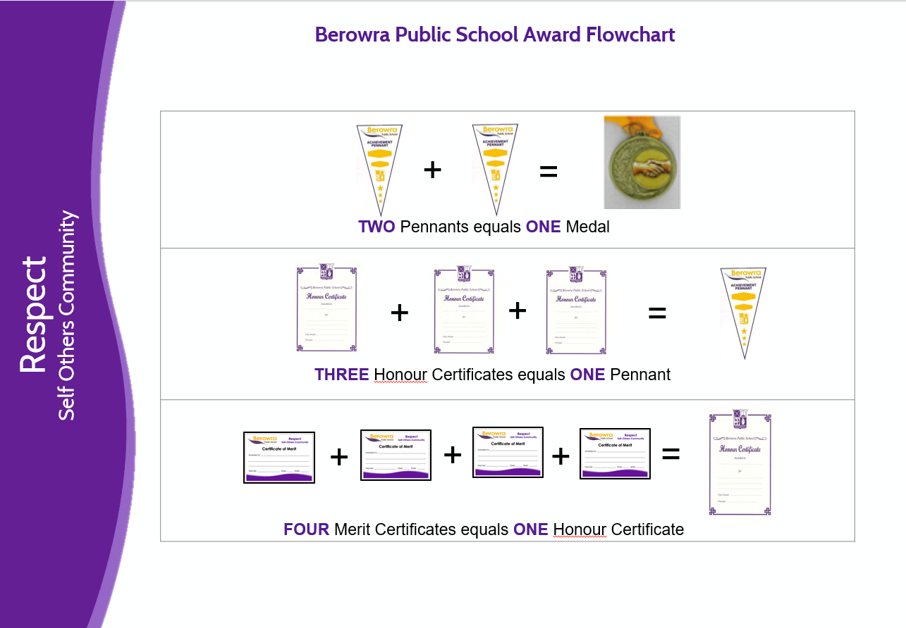
Gold Level
Silver Level
Bronze Level

Minor and Major Behaviour Incidents

Minor Behaviour Incidents |  | Major Behaviour Incidents
- Out of bounds  - Running on hard surfaces  - Playing in the toliets  - Playing after the bell  - Late to class  - Littering  - Disturbing games or harmony  - Swearing amoung students  - Calling others names  - Harrassing of others  - Climbing trees/fences  - Playing with sticks/stones  - Splashing water  - Without a hat in wrong area  - Standing up while eating  - Rough play  - Disobedience  - Minor classroom misbehaviour |  | - Physical and dangerous play (wrestling, tackling, biting, pushing, tripping, hitting, kicking, stomping, inappropriate touching)  - Throwing sticks, rocks or objects  - Inappropriate behaviour towards others eg dacking, sexual innuendo  - Inappropriate behaviour in the toilets  - Bullying (repeated verbal, physical, psychological, social or cyber)  - Demanding possessions/money to join in  - Open/loud swearing  - Engaging in or encouraging an act of violence or inappropriate behaviour  - Leaving school grounds without permission  - Graffiti  - Racism  - Open defiance to a person in authority eg disrespect, rudeness, swearing, lying, shouting  - Spitting  - Stealing  - Interfering with/or malicious deliberate damage to personal or school property

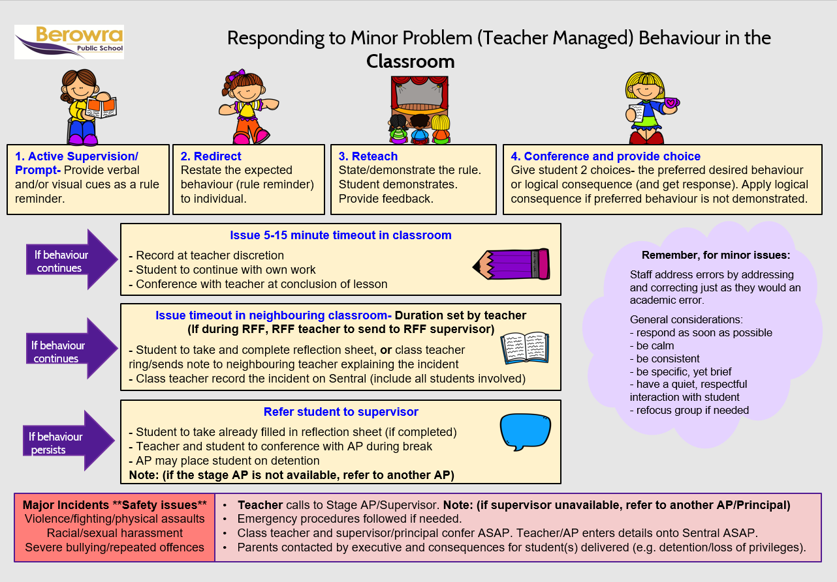
Classroom Management Procedures Flowchart

Playground Management Procedures Flowchart
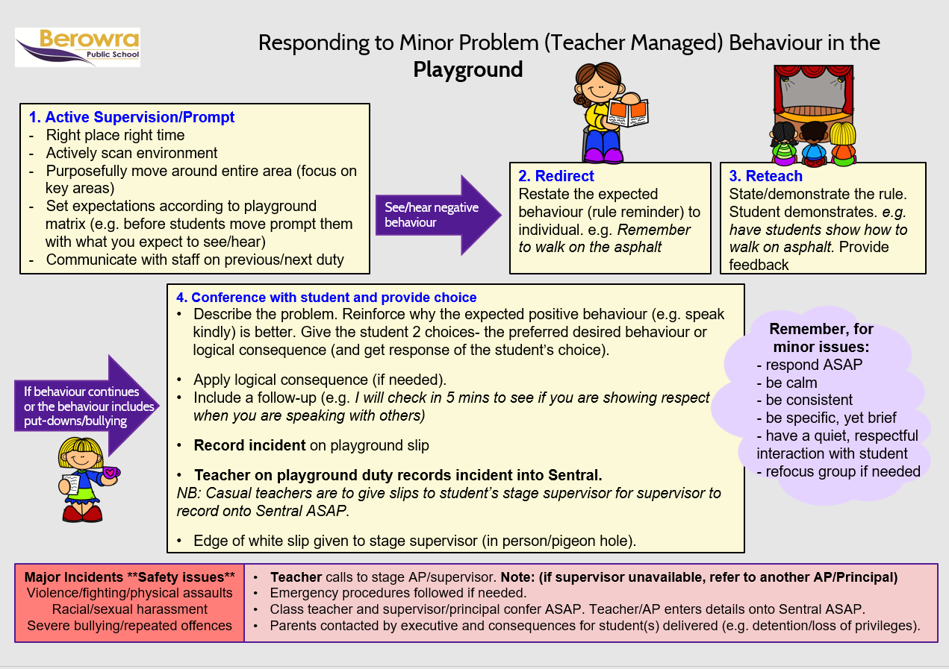

Behaviour Levels

demotion
Please note:
- Students are not demoted once they have achieved Award Levels (bronze, silver or gold)
- Teacher discretion used when representing certificates if student has been involved in recent negative incident/s.

Reflection Sheet

Name: Class: Date:

What did I do?
What school expectation did I not follow?
How did my actions impact others?
How can I fix the problem?
What will I do next time?

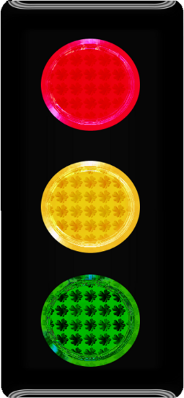

BEHAVIOUR CARD

NAME:

CLASS:

DATE:

My goal this week:

Area of play:
What worked this week?
STOP

THINK

DO

Behaviour Card

Student name: ___________________________________________ Class: _________ Term: _____ Week: ____
SESSIONS  Supervising staff member to print name | Day 1  DATE: | Day 2  DATE: | Day 3  DATE: | Day 4  DATE: | Day 5  DATE:
Before school
9:20am-10:20am
10:20am-11:20am
Recess
11:45am12:45pm
12:45pm-1:30pm
Lunch 1st half
Lunch 2nd half
2:20pm-3:20pm
Parent signature
Mark: Satisfactory Unsatisfactory

