Student Leadership Procedures

Our School Expectations
Respect:
- Self
- Others
- Community

Berowra Public School aims to produce informed, positive and effective citizens. By undertaking the role of a school leader, students will develop skills in decision making and an understanding of the rights and responsibilities of being part of a school community that values student voice and social justice. As a leader, students can demonstrate these values and skills to their peers and make a real contribution to strengthening the school and its community.

Leadership Opportunities at BPS
Student Leadership Team
(School Captains x2, Vice Captains x2, Prefects x6)

House Captains
(Wombats x2, Emus x2, Koalas x2, Kangaroos x2)

Student Parliament Representatives
(Prime Minister x1, Secretary x1, Treasurer x1, Ministers x8, Shadow Ministers x8, Sergeants of Arms)

Rationale
In today's changing world, our school leaders need to be given opportunities to develop leadership skills that will enable them to actively participate in the decision-making process.

Our school leaders must reflect on their role, set targets and assess their effectiveness in education and the wider community.

The student leadership team involves students having an input in decision making within the school.

Student leadership activities link strongly with learning about citizenship and the processes involved in a democracy. They can assist all students to learn the rights and responsibilities of participating in a community that values social justice.
Intended Outcomes
- Student leaders will develop skills for positive socially responsible participation.
- Student leaders understand that their views are important and they can have an influence on what happens in the school.
- Student leaders will apply leadership skills to initiatives which strengthen the school and its community.

Student Leadership Code of Conduct
Students who are elected by their peers and staff have an important responsibility to positively represent Berowra Public School.

They are expected to:
- always be in full school uniform
- always follow school expectations
- be helpful, thoughtful and respectful to other students
- take on leadership roles as requested

Year 5 Students Ineligibility to become a Student/School Leader
With privilege comes responsibility and consequences for actions. Any prospective school leader found to be in breach of the school’s expectations of ‘Respect for self, others and community’, will be subject to the following guidelines to determine suitability for all positions.
Eligibility of any student with recoded major incidents in Year 5 will be reviewed by the executive team. Any student who has received a suspension in Year 5 will be ineligible to run for leadership roles.
If your child is ineligible to become a school leader and they have nominated themselves a member of staff will contact parents/carers to discuss this.

Procedure for Disciplinary Action
of a School Leader
Student leaders have made a commitment to uphold school expectations and there will be consequences when leaders are not meeting these expectations.
- 1 recorded major incident - official warning.
- 2 recorded major incidents - lose their badge for one month.
- 3 recorded major incidents - lose their badge permanently.
Negative behaviour that does not follow school expectations may also affect attendance at one or more events including HZSS sport, representative sport teams (for example: zone, area, knock out teams), excursions, overnight excursions, Year 6 Mini Fete and Year 6 Farewell.
Procedure for Filling Positions after Elections
If a student relinquishes their position, loses their badge/position due to disciplinary action or leaves the school, the position will be filled by another eligible student. The student will be chosen by the Stage 3 teachers based on eligible students votes from the previous elections and the type and number of positions that they applied for during the previous elections.
Procedures and Timeline for
Student Leadership Team
- Year 5 students and parents are provided with the Student Leadership Policy with criteria required by students who wish to nominate for school leader and the responsibilities that accompany the position.
- Year 5 students who wish to run for student leadership will state their intent to run through the ‘Student Leadership Application’ and meet with the Stage 3 Assistant Principal to discuss their application.
- All Year 5 students who are eligible for nomination will be able to nominate themselves or be nominated by a peer. If nominated by a peer, a student has the right to decline the nomination. Each nomination must be seconded in order to be considered.
- School staff will view the nominations, to ensure all nominees fulfil the position criteria and are of good character. Sentral behaviour records will be consulted at this stage to assess if the nominee is upholding school expectations. The student’s classroom teacher/s, RFF teachers and QTSS teachers will be asked to ‘sign off’ on the student’s nomination. Three endorsements will be required.
- If there are more than twenty candidates nominated Year 5 students will vote to reduce the list to the required number of twenty. During this process Year 5 students will be issued with one ballot paper where they can vote for three (3) candidates.
- The successful candidates (20) will write a speech, which should include an outline of how they meet our school expectations (Respect for self, others and community) to present at a later assembly.
- Each candidate will deliver their speech at a special assembly. The audience will include all students in Years 2 – 6 and available staff.
- Using a ballot paper, students will vote after the speeches. Each student will be granted three votes for their leaders of choice.
- The ten candidates who obtain the most votes are elected.
- The two candidates with the highest vote are declared Captains, the next highest Vice Captains and the remaining six are declared Prefects. The Leadership Team (10 students) will be announced at a school assembly. Specific roles will be announced on Presentation Day with a badge presentation.
Position Criteria for School Leadership Team
It is expected that a member of the School Leadership Team will:
- show the ability to make decisions for themselves and without peer pressure.
- demonstrate exemplary behaviour while acting with integrity, honesty and respect.
- follow and uphold school expectations (Respect for self, others and community) at all times.
- show a willingness to be involved in extracurricular activities.
- display initiative.
- work well as a team member.
- possess strong communication skills (written / verbal / listening).

Student Leadership Team Job Expectations
Some responsibilities of our School Leadership Team include:
- running assemblies
- welcoming visitors to our school
- representing the school at functions
- responsibility for flags
- speaking at special school events
- assisting with Kindergarten Orientation Day activities
- communication around the school
- upholding Berowra Public School values and expectations
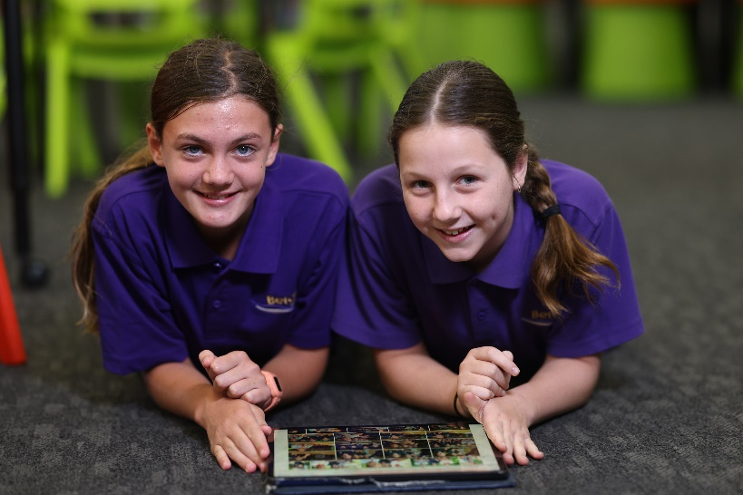

Procedures and Timeline for
House Captains
- Year 5 students and parents are provided with the Student Leadership Policy with criteria required by students who wish to nominate for school leader and the responsibilities that accompany the position.
- A meeting of all Year 5 students takes place and students are given an opportunity to make a nomination.
- School staff will view the nominations, to ensure all nominees fulfil the position criteria and are of good character. Sentral behaviour records will be consulted at this stage to assess if the nominee is upholding school expectations.
- Successful candidates are informed of their selection and are given permission notes and documentation to take home and discuss with their parents/caregivers.
- Candidates return the required paperwork and prepare a speech to present to their sporting house at a later date.

- Candidates present their speech to an audience of Year 2 – 6 members of their sporting house.

- Year 2 – 6 students allocate their one vote to elect candidates for their sporting house.

- Votes are tallied and the two candidates in each house with the highest number of votes are announced as sports leaders and presented with their badges at the School Presentation Day Assembly.

House Captain Job Expectations
Some responsibilities of our House Captains include:
- monitoring and delivering of sports equipment
- leading their house at sports events
- participating in sports to the best of their ability
- assisting with ‘Winning House’ events/rewards
- leading their house during all school carnival meetings
- set up sport equipment at the beginning of lunch

Position Criteria for House Captains
It is expected that a House Captain will:
- set a good example to other students in regards to sports-personship and participation in sport.
- show the ability to make decisions for themselves and without peer pressure.
- demonstrate exemplary behaviour while acting with integrity, honesty and respect.
- show a willingness to be involved in extracurricular activities.
- display initiative.
- work well as a team member.
- posses strong communication skills (written / verbal / listening).
- follow and uphold school expectations (Respect for self, others and community).

Procedures and Timeline for
Parliamentarians
- Year 5 students and parents are provided with the Student Leadership Policy with criteria required by students who wish to nominate for school leader and the responsibilities that accompany the position.
- Year 5 students are informed of the upcoming nominations during Term 4 and are given access to the position criteria, job expectations and responsibilities for Parliamentarians.

- After Presentation Day, a meeting of all Year 5 students takes place and students are given the opportunity to nominate themselves for a parliamentary position.

- At a convenient time after nominations, Year 5 vote for the Parliamentary positions by the way of a ballot paper.

- Votes are tallied and the students with the highest number of votes per position, will be the Parliamentarians for the following year.

- Positions are announced on the last Parliament for the year.

Position Criteria for Parliamentarians
It is expected that a Parliamentarian will:
- be an advocate for student voice.
- show the ability to make decisions for themselves and without peer pressure.
- demonstrate exemplary behaviour while acting with integrity, honesty and respect.
- show a willingness to be involved in extracurricular activities.
- display initiative.
- work well as a team member.
- possess strong communication skills (written / verbal / listening).
- follow and uphold school expectations
Roles and Responsibilities
for Parliamentarians
Parliamentary Position | Portfolio Expectations
Prime Minister | - Run/lead Parliament  - Conduct voting in Parliament  - Write ‘Thank You’ speeches and letters in response to change in the school  - Represent the school on special occasions
Treasurer  (+ Shadow Minister) | - Communicate effectively and respectfully with office staff regarding Parliamentary budget  - Approve money spent using Parliament funds
Secretary  (+ Shadow Minister) | - Parliamentary record keeping  - Taking minutes and recording notes in each Parliament  - Read and present motions at each Parliament  - Present a report at each Parliament
Minister for Sport  (+ Shadow Minister) | - Collaborate with House Captains to organise school sporting equipment  - Act on motions raised in Parliament regarding sport
Minister for Education  (+ Shadow Minister) | - Set up Parliament  - Say the Acknowledgment of Country  - Act on motions raised in Parliament related to Education
Minister for Communication and Technology  (+ Shadow Minister) | - Assist in organising displays in hall and foyer  - Assist in technology organisation in the library  - Act on motions raised in Parliament related to Communication  - Act on motions raised in Parliament related to Technology  - Take posters down after events  - Take photos at school events and share them with the Media Officer/Team  - Help kindergarten with logins when requested by teachers
Roles and Responsibilities
for Parliamentarians
Parliamentary Position | Portfolio Expectations
Minister for Functions and Services  (+ Shadow Minister) | - Advertise fundraising days and special events  - Help coordinate ideas for the Year 6 gift to the school after the mini fete  - Act on motions raised in Parliament related to Functions and Services
Minister for Health and Safety  (+ Shadow Minister) | - Help with Premiers Sporting Challenge organisation  - Return lunch baskets to the canteen  - Report hazards to office staff  - Act on motions raised in Parliament related to Health and Safety
Minister for the Environment  (+ Shadow Minister) | - Assist General Assistant and gardening teacher with school gardens  - Ensure school environment is kept clean and make suggestions for improvement  - Take the school recycling bins out to the curb  - Act on motions raised in Parliament related to Environment
Minister for Trade  (+ Shadow Minister) | - Assist in returning school lost property  - Assist in returning school lost property after school carnivals and events  - Return belongings found in the playground  - Act on motions raised in Parliament related to Trade
Sergeant of Arms | - Use bells to keep control in Parliament  - Hand out Gumleaf Gotchas in Parliament to those students who are following school expectations  - Assist with vote counting in Parliament

Student Leadership Application
Name: | Class: | Date:
What does leadership mean to you? Explain in detail.

What have you already done to prove you are a good leader?

Explain how you demonstrate respect for self, others and community.

Why do you want to be a leader?

Please give your completed application to _____________ by ________

